week5_0 Sample Microservices
01_ Implementing Edge Services for Routing and Filtering
SecurityConfig.java
package com.example.oauthlogin.config;
import org.springframework.context.annotation.Bean;
import org.springframework.context.annotation.Configuration;
import org.springframework.security.web.SecurityFilterChain;
import org.springframework.security.config.annotation.web.builders.HttpSecurity;
@Configuration
public class SecurityConfig {
@Bean
public SecurityFilterChain securityFilterChain(HttpSecurity http) throws Exception {
http
.authorizeHttpRequests(auth -> auth
.requestMatchers("/", "/error").permitAll()
.anyRequest().authenticated()
)
.oauth2Login();
return http.build();
}
}

UserController.java
package com.example.oauthlogin.controller;
import org.springframework.web.bind.annotation.GetMapping;
import org.springframework.web.bind.annotation.RestController;
import java.security.Principal;
import java.util.Map;

@RestController
public class UserController {
@GetMapping("/")
public String home() {
return "<h1>Welcome to the OAuth2 Login App</h1><a href=\"/user\">Login with Google</a>";
}
@GetMapping("/user")
public Principal user(Principal principal) {
return principal;
}
}

OauthLoginApplication.java
package com.example.oauthlogin;
import org.springframework.boot.SpringApplication;
import org.springframework.boot.autoconfigure.SpringBootApplication;
@SpringBootApplication
public class OauthLoginApplication {
public static void main(String[] args) {
SpringApplication.run(OauthLoginApplication.class, args);
}
}

application.properties
server.port=8080
spring.application.name=oauth-login
spring.security.oauth2.client.registration.google.client-id=257422719971-70bi69n1dl4mherkshd77sup724f7800.apps.googleusercontent.com
spring.security.oauth2.client.registration.google.client-secret=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
spring.security.oauth2.client.registration.google.scope=openid,profile,email
spring.security.oauth2.client.registration.google.redirect-uri={baseUrl}/login/oauth2/code/{registrationId}
spring.security.oauth2.client.registration.google.authorization-grant-type=authorization_code
spring.security.oauth2.client.provider.google.authorization-uri=https://accounts.google.com/o/oauth2/v2/auth
spring.security.oauth2.client.provider.google.token-uri=https://oauth2.googleapis.com/token
spring.security.oauth2.client.provider.google.user-info-uri=https://openidconnect.googleapis.com/v1/userinfo
spring.security.oauth2.client.provider.google.user-name-attribute=sub
OauthLoginApplicationTests.java
package com.example.oauthlogin;
import org.junit.jupiter.api.Test;
import org.springframework.boot.test.context.SpringBootTest;
@SpringBootTest
class OauthLoginApplicationTests {

@Test
void contextLoads() {
}
}
OUTPUT
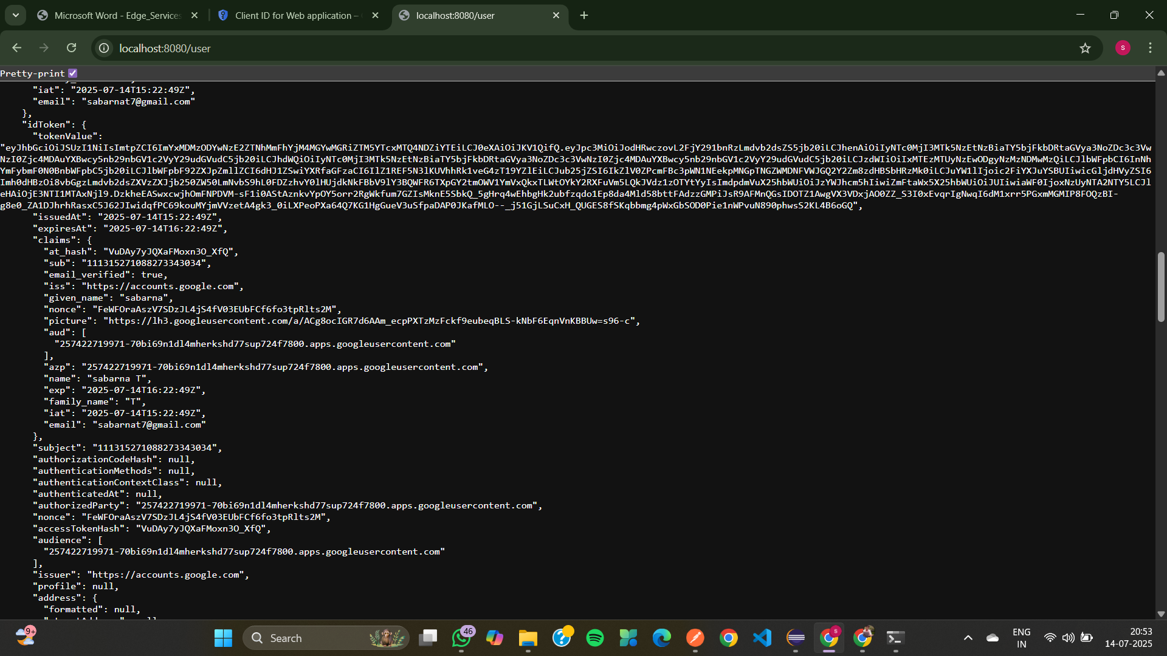
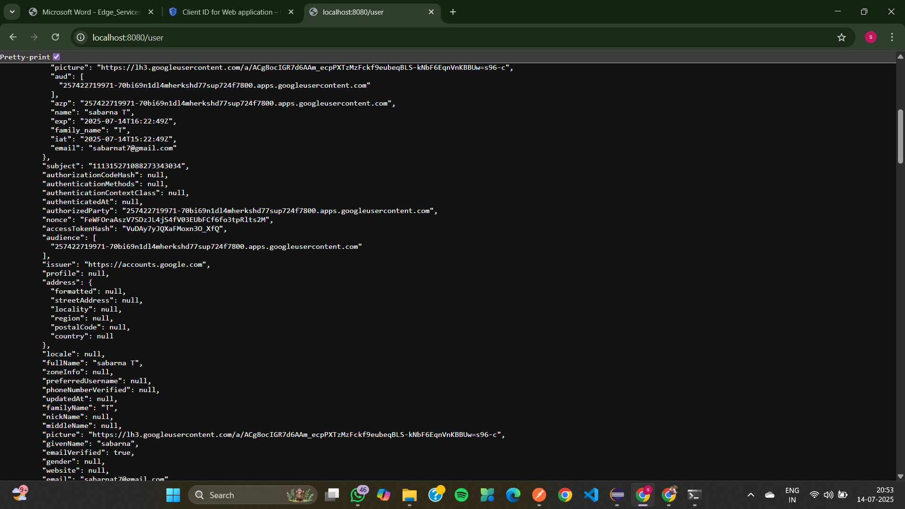
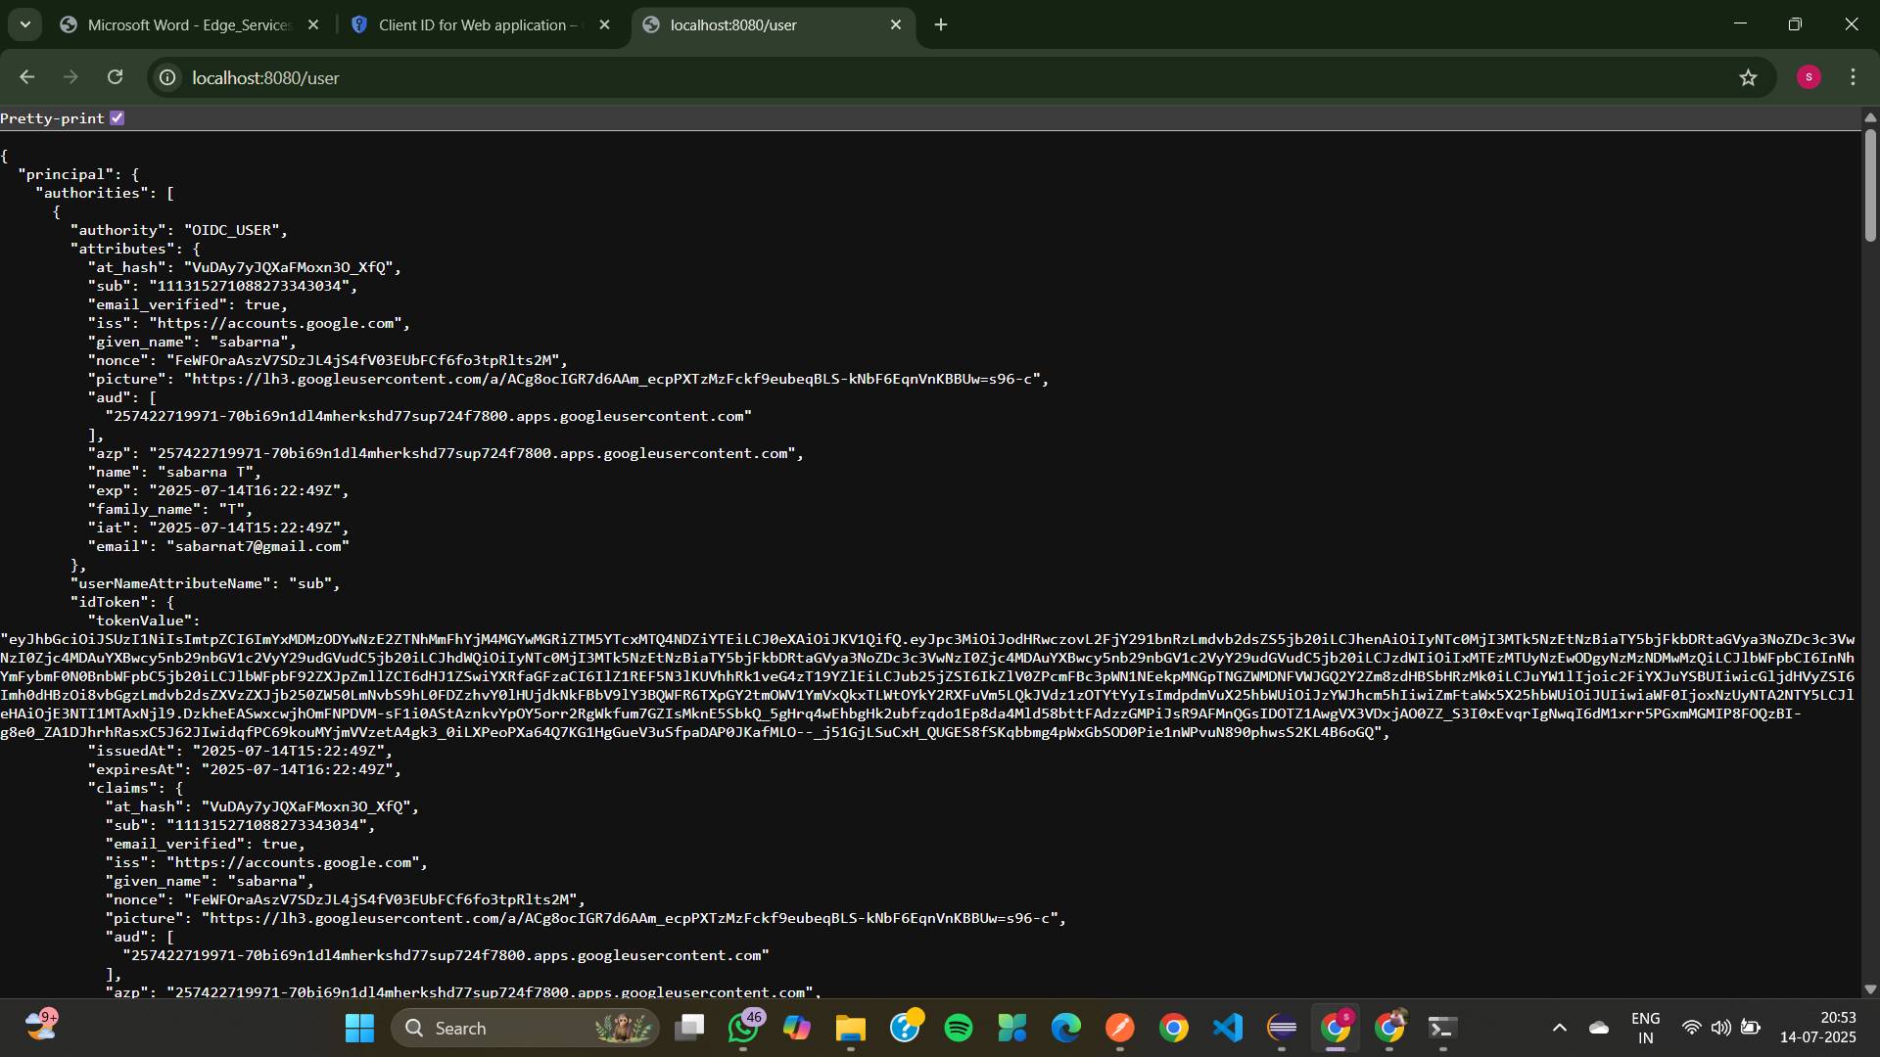
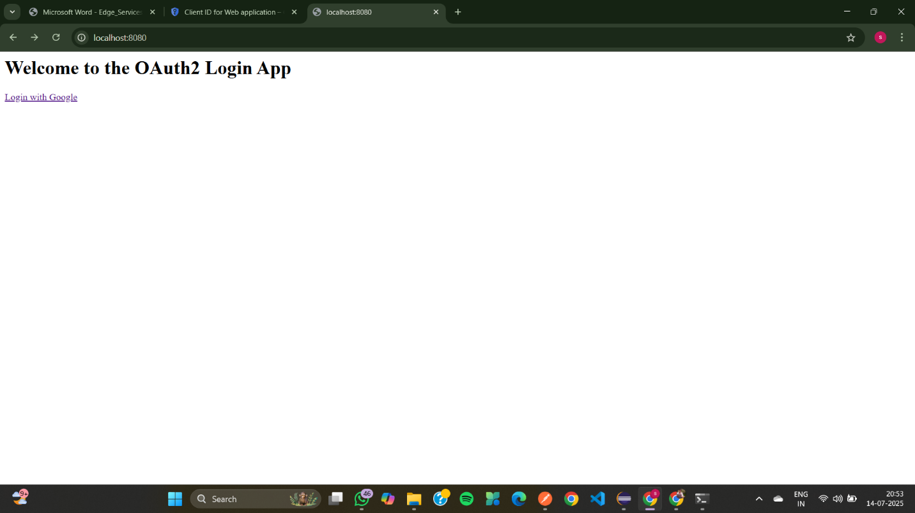
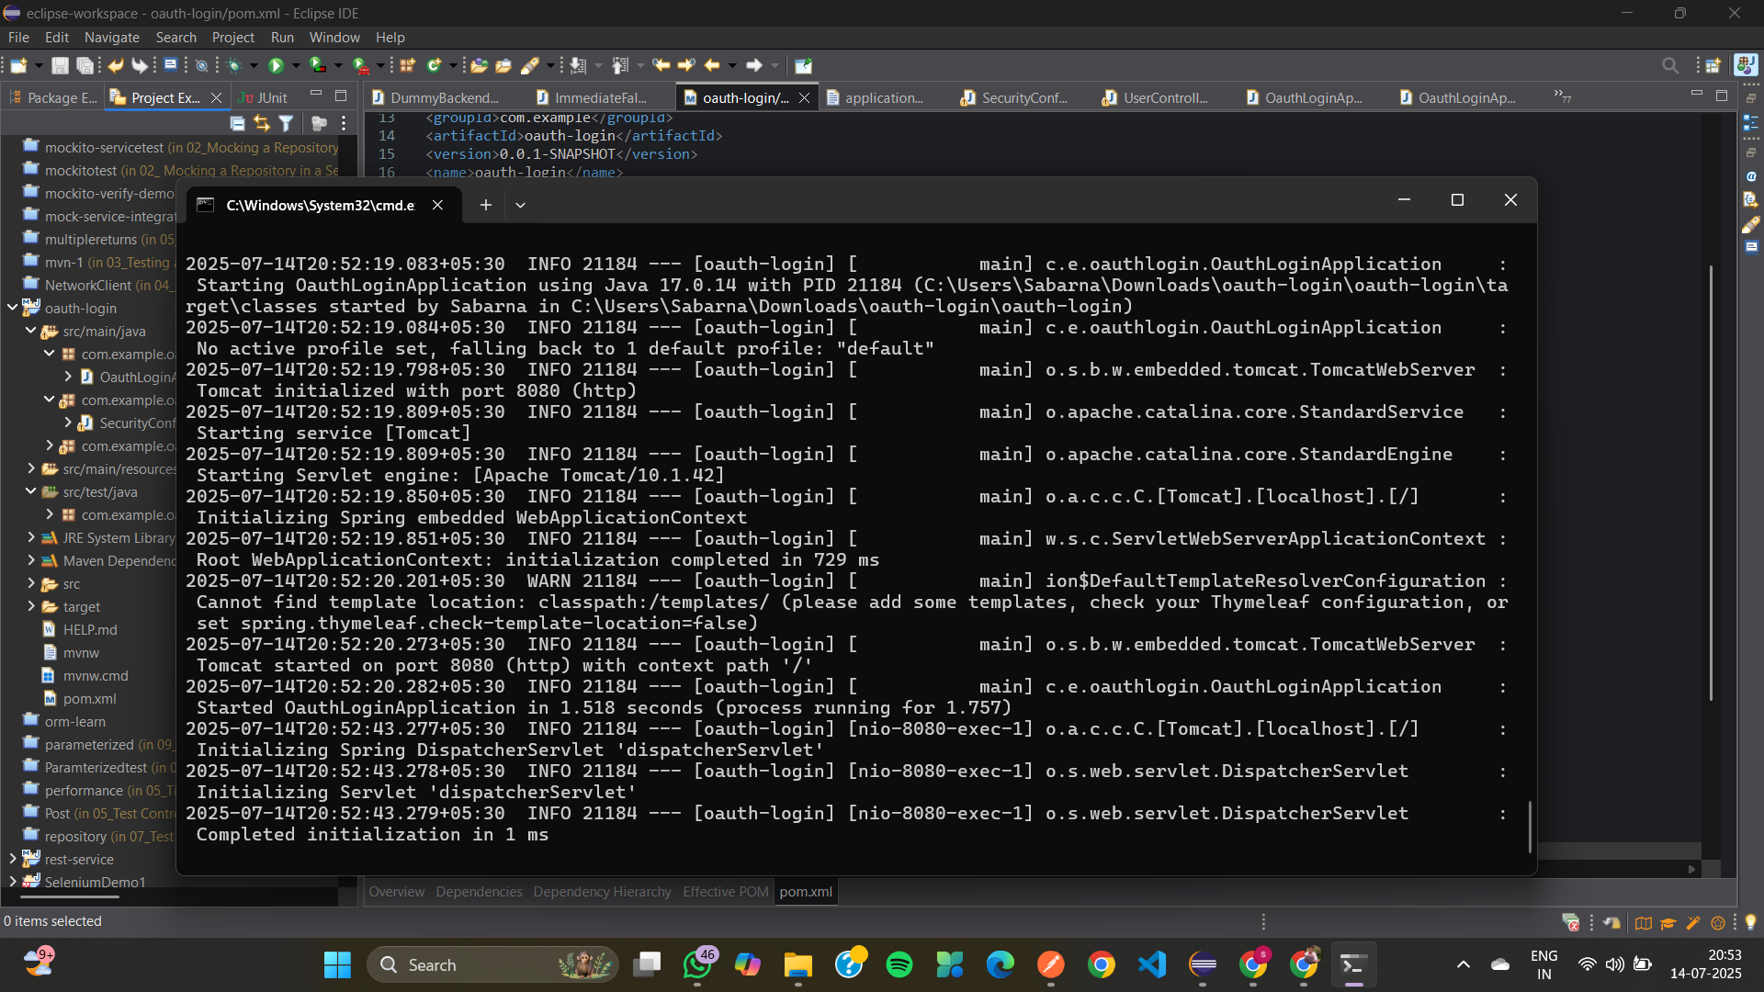
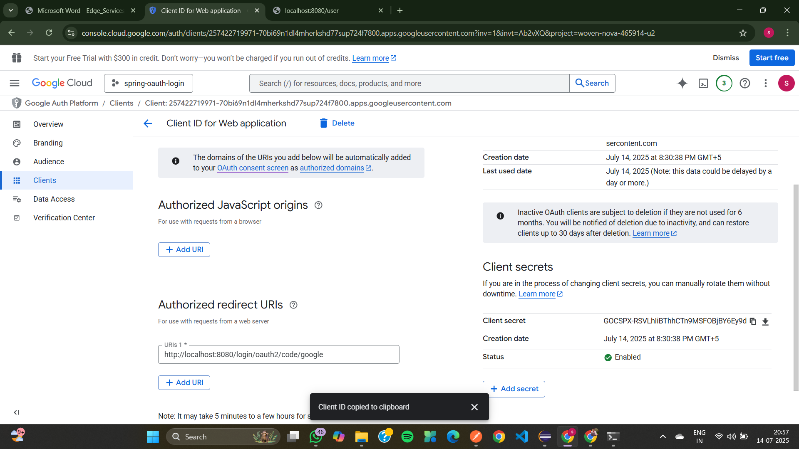

02_Configuring Authorization Servers and Resource Servers
SecureController.java
package com.example.controller;
import org.springframework.web.bind.annotation.GetMapping;
import org.springframework.web.bind.annotation.RestController;
@RestController
public class SecureController {
@GetMapping("/secure")
public String secureEndpoint() {
return " This is a secure endpoint!";
}
}

JwtSecureApp.java

package com.example.oauthlogin;

import org.springframework.boot.SpringApplication;

import org.springframework.boot.autoconfigure.SpringBootApplication;

@SpringBootApplication(scanBasePackages = "com.example")

public class JwtSecureApp {

public static void main(String[] args) {

SpringApplication.run(JwtSecureApp.class, args);

}

}

ResourceServerConfig.java
package com.example.security;
import org.springframework.context.annotation.Bean;
import org.springframework.context.annotation.Configuration;
import org.springframework.security.config.annotation.web.configuration.EnableWebSecurity;
import org.springframework.security.config.annotation.web.builders.HttpSecurity;
import org.springframework.security.web.SecurityFilterChain;
@Configuration
@EnableWebSecurity
public class ResourceServerConfig {
@Bean
public SecurityFilterChain securityFilterChain(HttpSecurity http) throws Exception {
http
.authorizeHttpRequests(auth -> auth
.anyRequest().authenticated() // 🔐 All requests now require authentication
)
.oauth2ResourceServer(oauth2 -> oauth2
.jwt() // ✅ Validate JWT tokens
);
return http.build();
}
}
application.properties
server.port=8080
spring.security.oauth2.resourceserver.jwt.issuer-uri=https://dev-ditamoyzjh3stnrq.us.auth0.com/

OauthLoginApplicationTests.java
package com.example.oauthlogin;
import org.junit.jupiter.api.Test;
import org.springframework.boot.test.context.SpringBootTest;
@SpringBootTest
class OauthLoginApplicationTests {
@Test
void contextLoads() {
}
}

OUTPUT
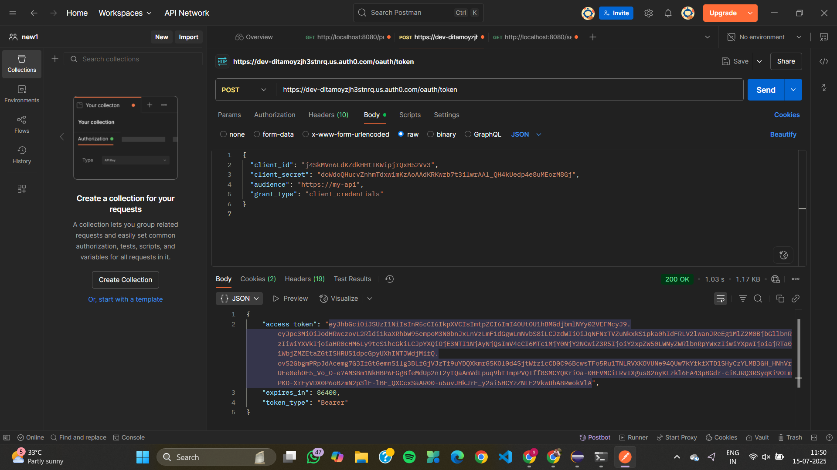
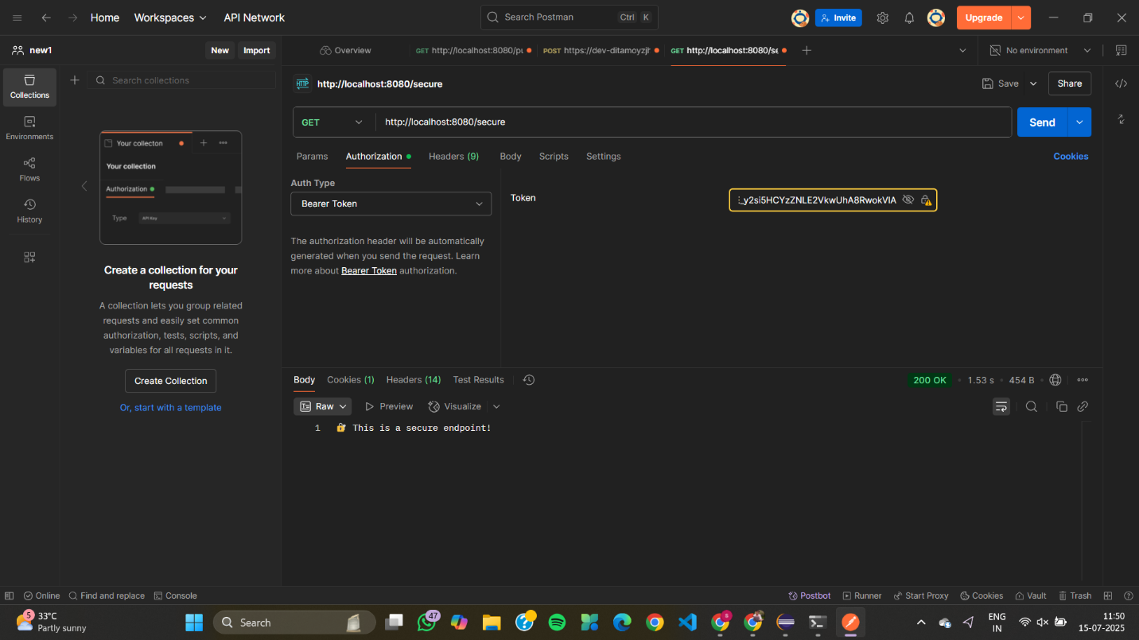

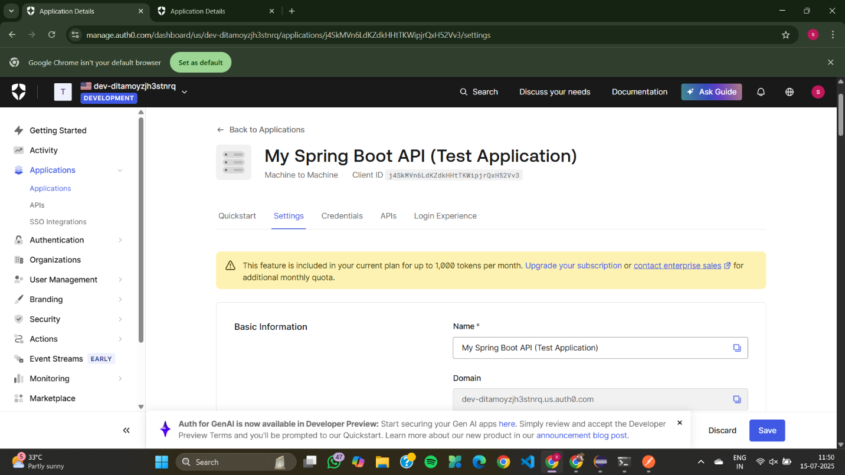
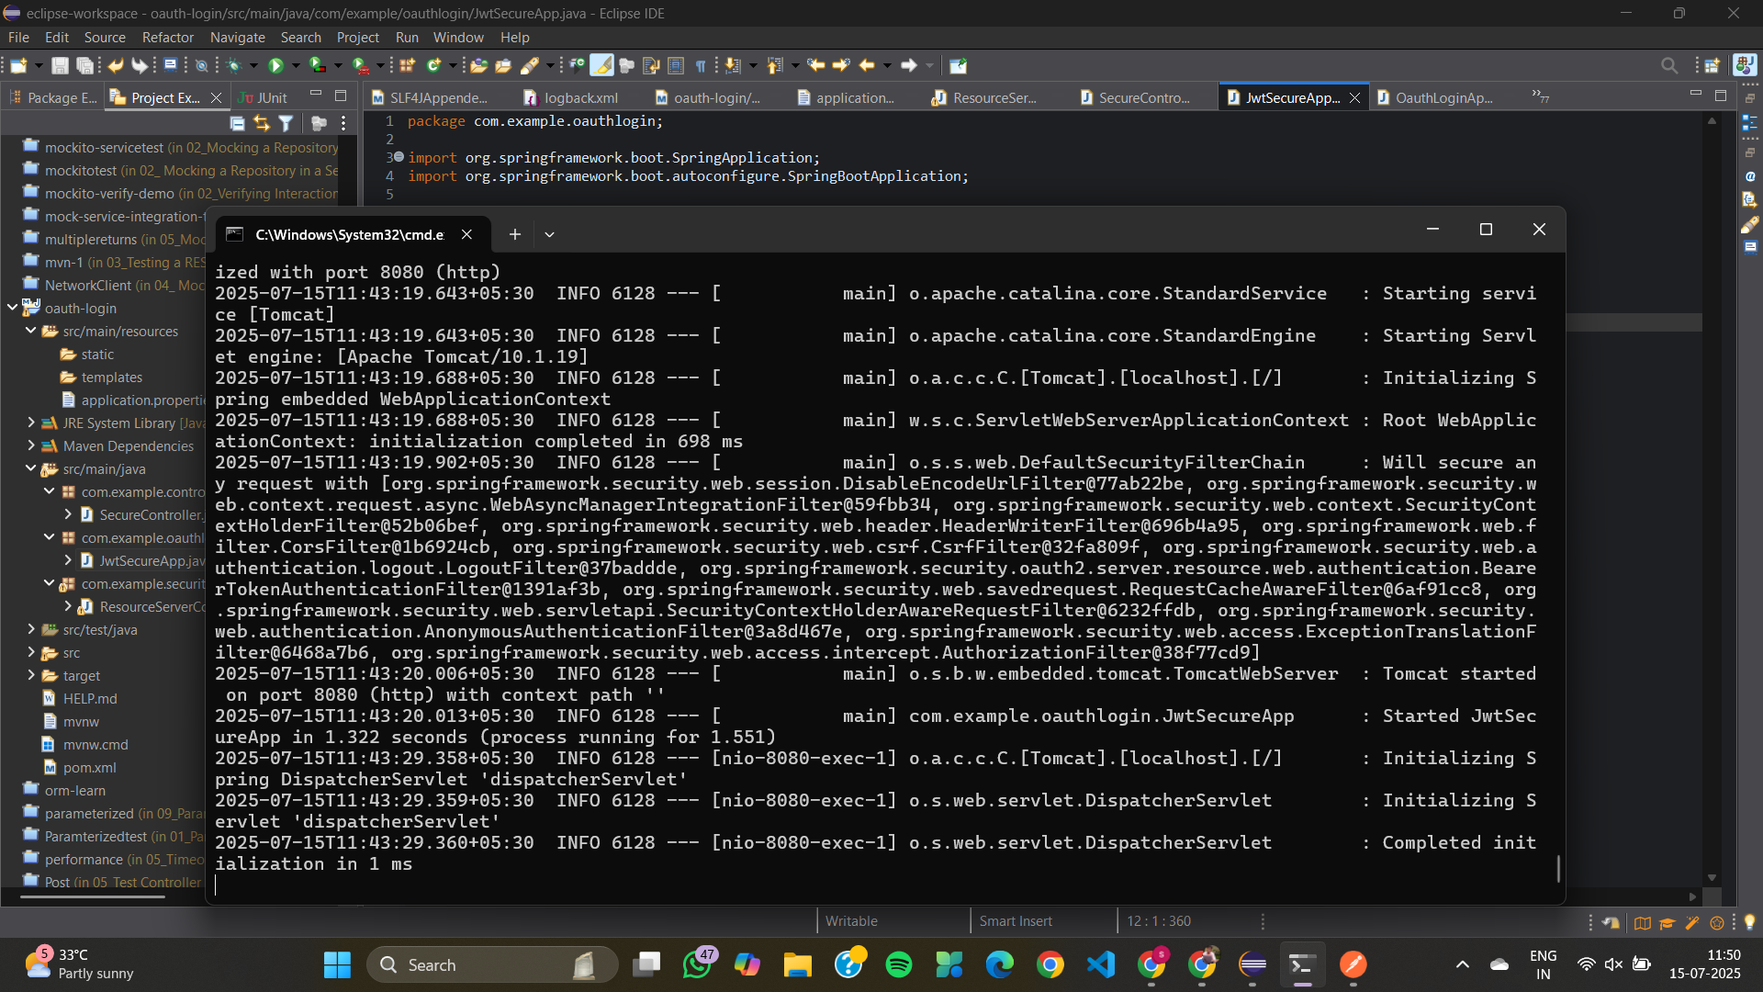

03_ Using JSON Web Tokens (JWT) for Secure Communication
JwtConfig.java
package com.example.jwt.config;
import org.springframework.beans.factory.annotation.Value;
import org.springframework.context.annotation.Configuration;
@Configuration
public class JwtConfig {
@Value("${spring.security.jwt.secret}")
private String secret;
public String getSecret() {
return secret;
}
}
SampleController.java
package com.example.jwt.controller;
import com.example.jwt.config.JwtTokenProvider;
import org.springframework.beans.factory.annotation.Autowired;
import org.springframework.http.ResponseEntity;
import org.springframework.web.bind.annotation.*;
@RestController
public class SampleController {
@Autowired
private JwtTokenProvider jwtTokenProvider;
@PostMapping("/auth/login")
public ResponseEntity<String> login(@RequestParam String username) {
String token = jwtTokenProvider.createToken(username);
return ResponseEntity.ok(token);
}
@GetMapping("/hello")
public ResponseEntity<String> hello() {
return ResponseEntity.ok("Hello, authenticated user!");
}
}
JwtDemoApplication.java
package com.example.jwt;

import org.springframework.boot.SpringApplication;
import org.springframework.boot.autoconfigure.SpringBootApplication;
@SpringBootApplication
public class JwtDemoApplication {
public static void main(String[] args) {
SpringApplication.run(JwtDemoApplication.class, args);
}
}
application.yml
spring:
security:
jwt:
secret: KiA5wOYTJKxy5+Z4TduJ6jL5O4KOPxpGd7rJ157YHGs=
JwtDemoApplicationTests.java
package com.example.jwt;
import org.springframework.boot.test.context.SpringBootTest;
import org.junit.jupiter.api.Test;
@SpringBootTest
public class JwtDemoApplicationTests {
@Test
void contextLoads() {
}
}
OUTPUT
